

**School of Engineering and Applied Science,**

**Ahmedabad University**

**CSE300 Software Engineering**

**Weekly Report**

**Guided By: Prof Khushru Doctor**

**TA Muskan Matwani**

**TA Anupama Nair**

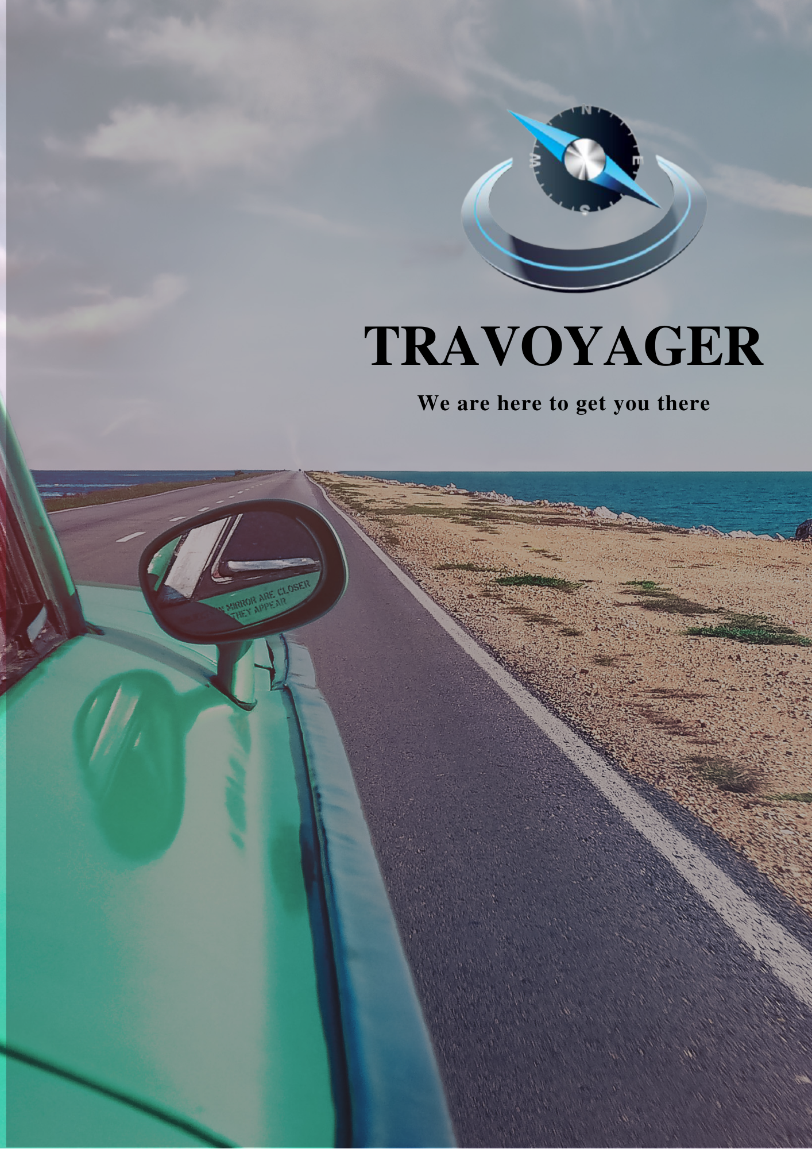

**WEEKLY MEETING REPORT - 1**

**Agenda** - Topic and Model Selection

**Date and Time**

**________________________________________________________________________________________________________________________________________________________________________________________________________________________________________________________________________________________________________________________________________________________________________________________________________________________________**

February 3, 2021 4:00-5:00P.M.

**Location**

**________________________________________________________________________________________________________________________________________________________________________________________________________________________________________________________________________________________________________________________________________________________________________________________________________________________________**

Google Meet

**Schedule**

**________________________________________________________________________________________________________________________________________________________________________________________________________________________________________________________________________________________________________________________________________________________________________________________________________________________________**

|  |  |
| --- | --- |
| **Time** | **Description** |
| 4:00-4:05 P.M. | Attendance |
| 4:05-4:20 P.M. | Finalizing the topic |
| 4:20-4:45 P.M. | Discussion on choosing the SE model |
| 4:45-5:00 P.M. | Selecting the SE model |
| 5:00-5:05 P.M. | Summary |
| 5:05 P.M. | Meeting Adjourned |

**Details**

**________________________________________________________________________________________________________________________________________________________________________________________________________________________________________________________________________________________________________________________________________________________________________________________________________________________________**

* From the topics discussed below:
  + Online Shopping System
  + Hotel Management System
  + Inventory Management System
  + Online Food Ordering
  + Online School Portal
  + Task Scheduling System
  + Travel Recommendation System
  + Stock Market Prediction System
* We finalized the topic ‘Travel Recommendation System’ as our project title.
* The models discussed for the project are as follows:
  + Waterfall model
  + V model
  + Incremental model
  + Spiral model
  + Concurrent model
  + Agile Scrum
  + Extreme Programming
* Finalized the Agile Scrum model.

**Conclusion**

**________________________________________________________________________________________________________________________________________________________________________________________________________________________________________________________________________________________________________________________________________________________________________________________________________________________________**

Finalization of the topic and the SE model

**Next Meeting Details**

**________________________________________________________________________________________________________________________________________________________________________________________________________________________________________________________________________________________________________________________________________________________________________________________________________________________________**

February 7, 2021 11:00A.M. - 12:00P.M.

**Next Agenda**

**________________________________________________________________________________________________________________________________________________________________________________________________________________________________________________________________________________________________________________________________________________________________________________________________________________________________**

Survey Conduct Preparation